Apache is an open source web server software created and maintained by Apache software foundation. Since it an open source so it is free to use. It is a web server used for one or more HTTP based websites. It is widely used by web hosting companies to provide shared and virtual hosting.

sudo chmod -R 777 /var/www

sudo chmod -R 777 /var/www

**Steps to install the Apache server:**

* **Make Superuser:** Open terminal and use following command to make yourself superuser.  
  sudo su  
  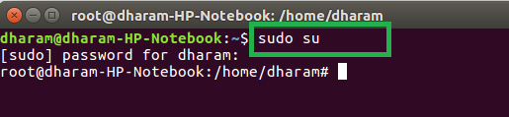
* **Update Ubuntu package:** Use the following command to update the Ubuntu package list.  
  sudo apt update  
  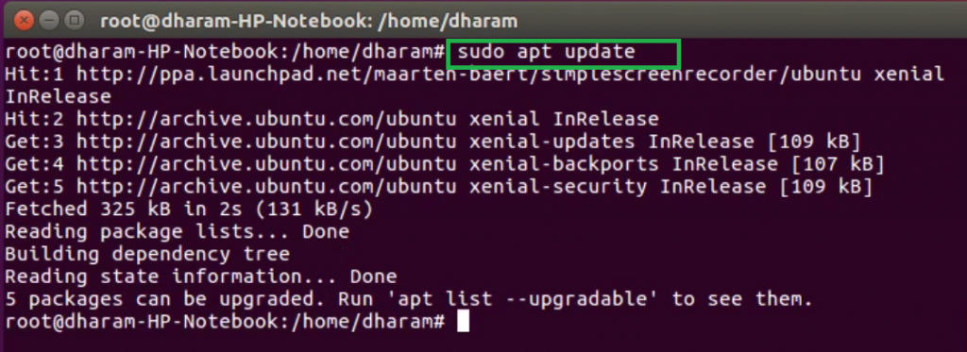
* **Install Apache:** After installing the Ubuntu package list, use the following command to install apache server.  
  sudo apt install apache2  
  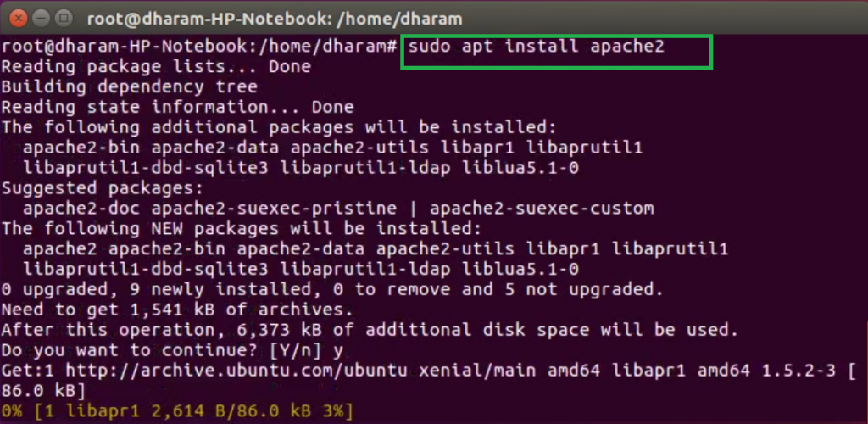
* After completion of the installation process, the Apache server automatically start. The status of the Apache server can be checked by using the following command.  
  sudo systemctl status apache2  
  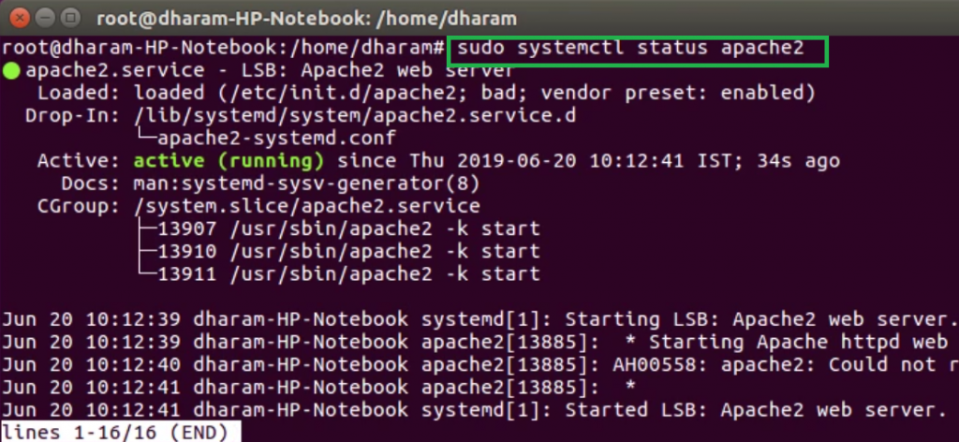
* Open the browser and type localhost or 127.0.0.1 on the address bar. It will display the default page of the Apache server.  
  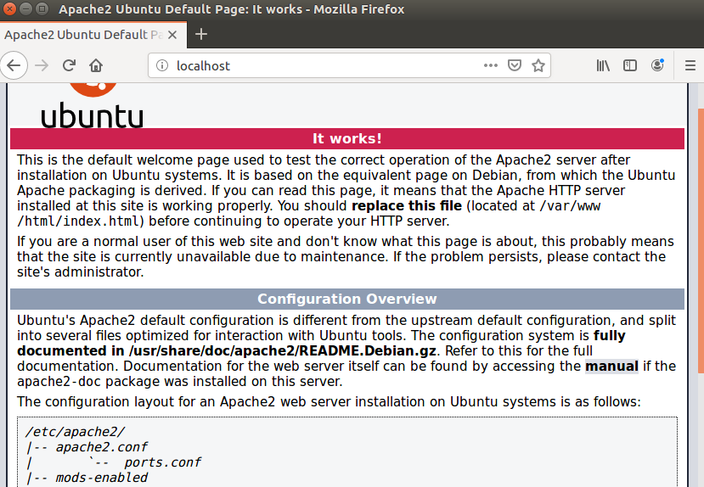



Like2

[Previous](https://www.geeksforgeeks.org/how-to-install-imagemagick-and-imagick-php-extension-in-ubuntu/)

[How to Install ImageMagick and Imagick PHP extension in Ubuntu?](https://www.geeksforgeeks.org/how-to-install-imagemagick-and-imagick-php-extension-in-ubuntu/)

[Next](https://www.geeksforgeeks.org/html-track-label-attribute/)

[HTML | <track> label Attribute](https://www.geeksforgeeks.org/html-track-label-attribute/)

Related Articles

**1.**

[Difference between Apache Tomcat server and Apache web server](https://www.geeksforgeeks.org/difference-between-apache-tomcat-server-and-apache-web-server/?ref=rp)

**2.**

[How to install and configure Apache Web Server on Godaddy Server?](https://www.geeksforgeeks.org/how-to-install-and-configure-apache-web-server-on-godaddy-server/?ref=rp)

**3.**

[How to Set Up Apache Web Server in AWS EC2 Linux (Ubuntu) Instance?](https://www.geeksforgeeks.org/how-to-set-up-apache-web-server-in-aws-ec2-linux-ubuntu-instance/?ref=rp)

**4.**

[How to Install Apache with PHP-FPM on Ubuntu?](https://www.geeksforgeeks.org/how-to-install-apache-with-php-fpm-on-ubuntu/?ref=rp)

**5.**

[How to Install Apache Cassandra on Ubuntu](https://www.geeksforgeeks.org/how-to-install-apache-cassandra-on-ubuntu/?ref=rp)

**6.**

[How to install and set up Apache Virtual Hosts on Ubuntu?](https://www.geeksforgeeks.org/how-to-install-and-set-up-apache-virtual-hosts-on-ubuntu/?ref=rp)

**7.**

[How to install and configure Apache Tomcat 10 on Godaddy Server?](https://www.geeksforgeeks.org/how-to-install-and-configure-apache-tomcat-10-on-godaddy-server/?ref=rp)

**8.**

[How to install the NFS server on Ubuntu?](https://www.geeksforgeeks.org/how-to-install-the-nfs-server-on-ubuntu/?ref=rp)

**9.**

[How to install and setup the OpenVPN server on Ubuntu/Debian?](https://www.geeksforgeeks.org/how-to-install-and-setup-the-openvpn-server-on-ubuntu-debian/?ref=rp)

**10.**

[How to Install GUI on Ubuntu Server?](https://www.geeksforgeeks.org/how-to-install-gui-on-ubuntu-server/?ref=rp)

**Article Contributed By :**



[Dharmendra_Kumar](https://auth.geeksforgeeks.org/user/Dharmendra_Kumar/articles)

[@Dharmendra_Kumar](https://auth.geeksforgeeks.org/user/Dharmendra_Kumar)

**Vote for difficulty**

EasyNormalMediumHardExpert

Article Tags :

* [how-to-install](https://www.geeksforgeeks.org/tag/how-to-install/)
* [How To](https://www.geeksforgeeks.org/category/how-to/)
* [Installation Guide](https://www.geeksforgeeks.org/category/techtips/installation-guide/)
* [PHP](https://www.geeksforgeeks.org/category/php/)
* [PHP Programs](https://www.geeksforgeeks.org/category/php-programs/)
* [Web Technologies](https://www.geeksforgeeks.org/category/web-technologies/)

Practice Tags :

* [PHP](https://practice.geeksforgeeks.org/explore?category%5B%5D=PHP)

Improve Article

Report Issue

WHAT'S NEW



[Hiring Challenge: 4th-5th Jan, 2023](https://practice.geeksforgeeks.org/events/rec/job-a-thon?utm_source=geeksforgeeks&utm_medium=rightbar_jobathon_default&utm_campaign=megajob2023)

**[Apply For 30+ Companies](https://practice.geeksforgeeks.org/events/rec/job-a-thon?utm_source=geeksforgeeks&utm_medium=rightbar_jobathon_default&utm_campaign=megajob2023)**

[View Details](https://practice.geeksforgeeks.org/events/rec/job-a-thon?utm_source=geeksforgeeks&utm_medium=rightbar_jobathon_default&utm_campaign=megajob2023)

[](https://practice.geeksforgeeks.org/events/rec/job-a-thon?utm_source=geeksforgeeks&utm_medium=rightbar_jobathon_default&utm_campaign=megajob2023)

[System Design- Live Classes](https://practice.geeksforgeeks.org/courses/system-design-live?utm_source=geeksforgeeks&utm_medium=rightbar_sdlive_default&utm_campaign=inbound_promotions)

[View Details](https://practice.geeksforgeeks.org/courses/system-design-live?utm_source=geeksforgeeks&utm_medium=rightbar_sdlive_default&utm_campaign=inbound_promotions)

[](https://practice.geeksforgeeks.org/courses/system-design-live?utm_source=geeksforgeeks&utm_medium=rightbar_sdlive_default&utm_campaign=inbound_promotions)

[DSA- Live Classes](https://practice.geeksforgeeks.org/courses/geeks-classes-live?utm_source=geeksforgeeks&utm_medium=rightbar_dsalive_default&utm_campaign=inbound_promotions)

[View Details](https://practice.geeksforgeeks.org/courses/geeks-classes-live?utm_source=geeksforgeeks&utm_medium=rightbar_dsalive_default&utm_campaign=inbound_promotions)

A-143, 9th Floor, Sovereign Corporate Tower,

Sector-136, Noida, Uttar Pradesh - 201305

feedback@geeksforgeeks.org

* Company
* [About Us](https://www.geeksforgeeks.org/about/?ref=footer)
* [Careers](https://geeksforgeeks.zohorecruit.in/careers)
* [In Media](https://www.geeksforgeeks.org/press-release/?ref=footer)
* [Contact Us](https://www.geeksforgeeks.org/about/contact-us/?ref=footer)
* [Privacy Policy](https://www.geeksforgeeks.org/privacy-policy/?ref=footer)
* [Copyright Policy](https://www.geeksforgeeks.org/copyright-information/?ref=footer)
* [Advertise with us](https://www.geeksforgeeks.org/advertise-with-us/?ref=footer)
* Learn
* [DSA](https://www.geeksforgeeks.org/learn-data-structures-and-algorithms-dsa-tutorial/?ref=footer)
* [Algorithms](https://www.geeksforgeeks.org/fundamentals-of-algorithms/?ref=footer)
* [Data Structures](https://www.geeksforgeeks.org/data-structures/?ref=footer)
* [SDE Cheat Sheet](https://www.geeksforgeeks.org/gfg-sde-sheet-a-complete-guide-for-sde-preparation/?ref=footer)
* [Machine learning](https://www.geeksforgeeks.org/machine-learning/?ref=footer)
* [CS Subjects](https://www.geeksforgeeks.org/articles-on-computer-science-subjects-gq/?ref=footer)
* [Video Tutorials](https://www.geeksforgeeks.org/videos/?ref=footer)
* [Courses](https://practice.geeksforgeeks.org/courses/?ref=footer)
* [News](https://news.geeksforgeeks.org/?ref=footer)
* [Top News](https://news.geeksforgeeks.org/top?ref=footer)
* [Technology](https://news.geeksforgeeks.org/technology?ref=footer)
* [Work & Career](https://news.geeksforgeeks.org/work-career?ref=footer)
* [Business](https://news.geeksforgeeks.org/business?ref=footer)
* [Finance](https://news.geeksforgeeks.org/finance?ref=footer)
* [Lifestyle](https://news.geeksforgeeks.org/lifestyle?ref=footer)
* [Knowledge](https://news.geeksforgeeks.org/knowledge?ref=footer)
* Languages
* [Python](https://www.geeksforgeeks.org/python-programming-language/?ref=footer)
* [Java](https://www.geeksforgeeks.org/java/?ref=footer)
* [CPP](https://www.geeksforgeeks.org/c-plus-plus/?ref=footer)
* [Golang](https://www.geeksforgeeks.org/golang/?ref=footer)
* [C#](https://www.geeksforgeeks.org/csharp-programming-language/?ref=footer)
* [SQL](https://www.geeksforgeeks.org/sql-tutorial/?ref=footer)
* [Kotlin](https://www.geeksforgeeks.org/kotlin-programming-language/?ref=footer)
* Web Development
* [Web Tutorials](https://www.geeksforgeeks.org/web-development/?ref=footer)
* [Django Tutorial](https://www.geeksforgeeks.org/django-tutorial/?ref=footer)
* [HTML](https://www.geeksforgeeks.org/html-tutorials/?ref=footer)
* [JavaScript](https://www.geeksforgeeks.org/javascript-tutorial/?ref=footer)
* [Bootstrap](https://www.geeksforgeeks.org/bootstrap-tutorials/?ref=footer)
* [ReactJS](https://www.geeksforgeeks.org/reactjs-tutorials/?ref=footer)
* [NodeJS](https://www.geeksforgeeks.org/nodejs/?ref=footer)
* Contribute
* [Write an Article](https://www.geeksforgeeks.org/contribute/?ref=footer)
* [Improve an Article](https://www.geeksforgeeks.org/how-to-improve-an-article/?ref=footer)
* [Pick Topics to Write](https://write.geeksforgeeks.org/pick-article?ref=footer)
* [Write Interview Experience](https://www.geeksforgeeks.org/write-interview-experience/?ref=footer)
* [Internships](https://www.geeksforgeeks.org/careers/?job_type=1&ref=footer)
* [Video Internship](https://script.geeksforgeeks.org/on-boarding/youtube?ref=footer)

[@geeksforgeeks](https://www.geeksforgeeks.org/) , [Some rights reserved](https://www.geeksforgeeks.org/copyright-information/)

We use cookies to ensure you have the best browsing experience on our website. By using our site, you acknowledge that you have read and understood our [Cookie Policy](https://www.geeksforgeeks.org/cookie-policy/) & [Privacy Policy](https://www.geeksforgeeks.org/privacy-policy/)Got It !

Lightbox

## **Start Your Coding Journey Now!**

LoginRegister